# Softera – Brand Brief

## 1. About the Brand

Softera is a brand-new furniture label that’s just starting out. We specialize in simple, modern, practical wooden furniture at affordable prices.  
We are launching our social media presence, and this will be the brand’s very first appearance online.

We are looking for:

* A short, expressive **Instagram Bio** that captures the essence of the brand
* A **first welcome/introductory post** that introduces Softera in a friendly and engaging way
* **Two product posts** describing different furniture pieces, along with suitable hashtags

The goal of the first post is to give people a clear and appealing idea of what Softera is all about — in a tone that feels young, simple, and relatable.

## 2. Target Audience

- Age: 20–38 years old  
- Young professionals, students, or newlyweds furnishing their first home  
- Looking for affordable, stylish, space-saving wooden furniture  
- Care about practicality, design, and price

## 3. Brand Voice

Warm, friendly, simple, and youthful. Softera speaks like a helpful friend who gets your lifestyle—no complications, just beautiful, practical design.

## 4. Deliverables Requested from Freelancer

- 1 Instagram Bio (short, expressive, matching the brand tone)  
- 3 Social Media Posts:  
 1. Introduction post about the brand  
 2. Product post #1   
 3. Product post #2

- Include relevant hashtags for each post

## 5. Product Images

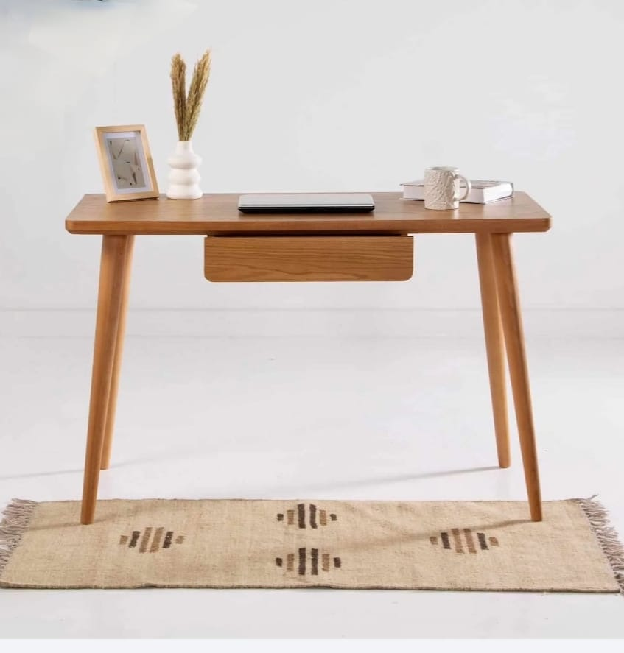

**Dimensions**

Width 120 cm

Depth 60cm

Height 78cm

**Wood**

The desk is made of:

* MDF board imported from Thailand, covered with a melamine layer that is water-resistant, shock-resistant, and treated to withstand heat and hot beverages.
* Legs made of solid red Zaan wood, detachable and easy to assemble.

Available in white, wood brown, and black colors.

**Price**

1500 EGY

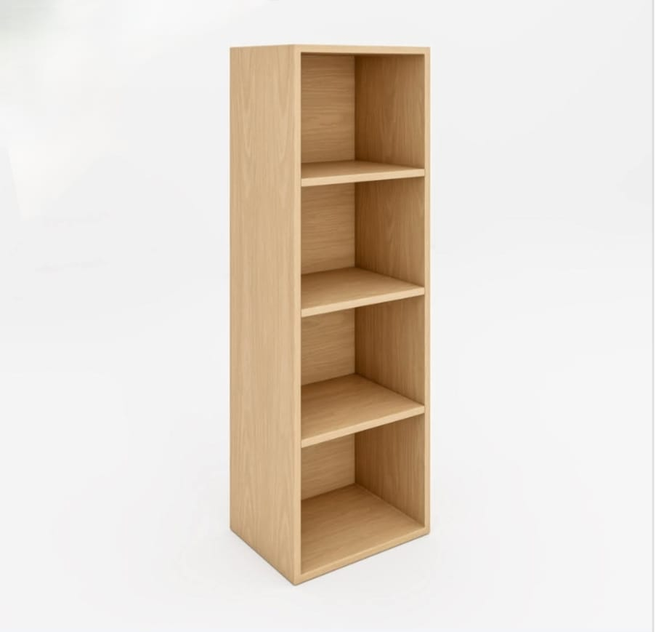

* Made from high-quality MDF with melamine coating
* Custom sizes available upon request
* Available colors: Wood, White, Black

**Facebook**

https://www.facebook.com/profile.php?id=61575511847052&locale=ar_AR